How to Access Testing Center Exam Results

Go to https://testing.byu.edu/node?destination=node

Sign In (use your Net ID and Password)

Click on Faculty, then Exam Detail

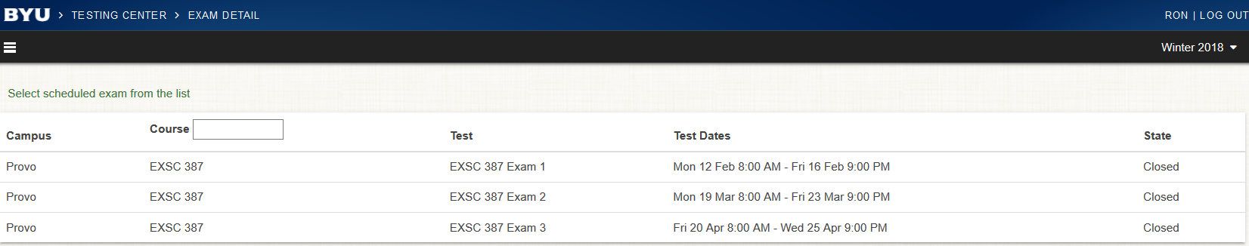

You will see the exams for the sections you teach, including test dates. Click on the row of the class for which you want to see results

Click on View to see the exam results.

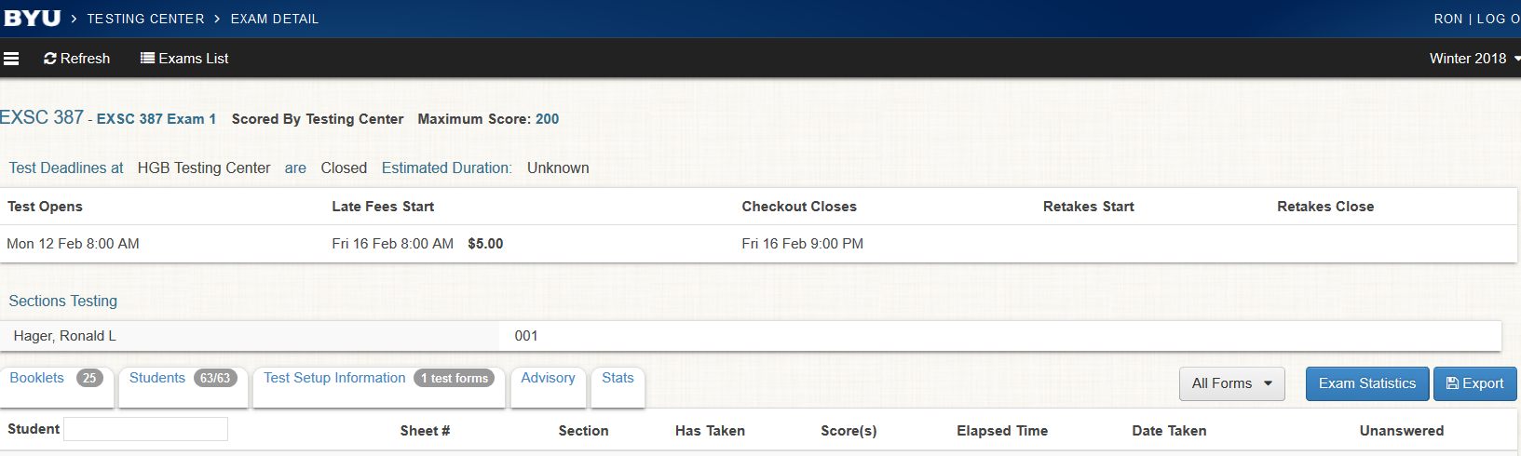

You will be able to see the list of all students who have taken the exam, their Net ID, Score, and Percent Grade.

If you click on the blue buttons to the right, you can get Exam Statistics (with Question Details) and you have the option to Export the data (Tests = Excel spreadsheet with Name, BYU ID, Net ID, Section #, Course Number, Percent, and Elapsed Time (mins) or Responses = Form, Name, Net ID, undefined, Entry Time, Question # and correct response (column for each question)). There are other options available (Booklets, Students, Test Setup Information, Advisory, Stats).

